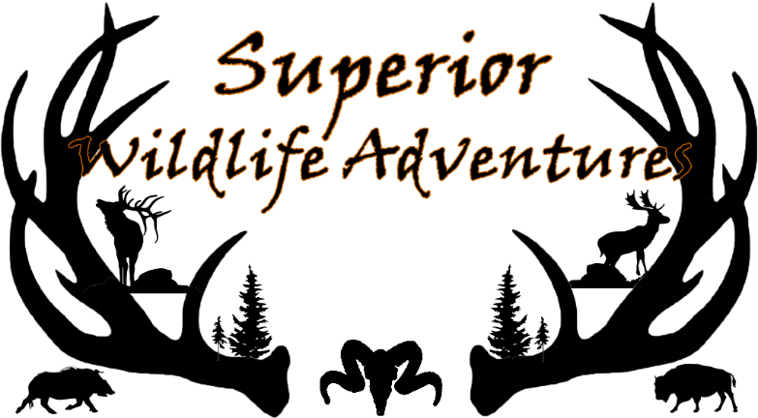
Packing Checklist
Clothes (suggestions):
- Camo clothing
- At least one item of hunter blaze orange
- Hunting boots or insulated boots
- Street shoes and street clothes
- Slippers to keep cabin free from dirt and blood
- Socks, three or four pairs of warm hunting socks
- Gloves or shooting mittens
- Long underwear or under garments to keep warm
- Hat- weather appropriate
- Rain Gear
- Camo face mask, net or paint (type of hunt, if needed)
Hunt Equipment (suggestions or just for fun):
- Rifle, Shotgun, Muzzleloader or Handgun
- Bow or Crossbow - (back-up: extra quick release)
- Back-up or 2nd type of weapon - (in case you choose another hunt or method of hunting)
- Ammunition or arrows -(bring extra if sighting-in is needed)
- Expandable broadheads are NOT recommended
- Animal calls for deer - if desired
- Range finder
- Knife or Multi-tool
- Binoculars
- Hunting pack or fanny pack
- Shooting glasses or sunglasses
- Flashlight
- If sighting-in, earplugs and shooting glasses
Misc. Items and Equipment (suggestions):
- Coolers (ice chests) to transport your meat
- Scent eliminator products
- Camera or video camera
- Extra batteries, memory cards
- Eyeglasses or sunglasses
- Prescriptions or over-the-counter medications
- Insect spray
- MI license - for in season wild hunts only
- Food, candy or snacks for between meals (we provide water/soda)
- Thermos bottle

